|  |
| --- |
| ENCS 282, section BB, Assignment 5: Proposal |
| MyConcordia Portal Application |
| Professor: Grimes, K Tutor: Crosthwait, C.J |



|  |
| --- |
| 11/27/2012 |

***1. Abstract***

This project creates a smartphone application to solve students current problem with the mobile my Concordia website and improve their current experience. The idea is to develop an Application that will contain most used utilities needed by students in their everyday life as Concordia students. It will improve the speed of access to the information for the students, giving a user-friendly interface while providing the necessary utilities. It will definitely be used alternative the main website while in the same be available on the go, anywhere where student have internet access. It will require 2 teams of developer to produce the same product in different type of smartphone. It will require an important sum of money to be developed but in the same time it could prove to be a major source of income the university. This proposal will indicate the required guidelines to develop this application and the requirements to make it into a huge success.

***2.Letter Of Transmittal***

***Student in Software Engineering at Concordia University***

***3333 Rue GUY H3H 9T2***

***November 24th, 2012***

***Lilia VINCI***

***Concordia Internet & Server Supervisor***

***8143 Rue ST CATHERINE H3H 5Y6***

Dear VINCI,

I’m addressing this letter to you, hoping to promote the creation of a My Concordia smartphone application that will enhance the student experience while providing extra income to Concordia University.

I believe with the available resource in Concordia, we will be able to develop an application responding to student needs. It will contain the most important functionality like Registration, Class Schedule, Moodle, Concordia Webmail, Grades, Exam Schedule and more. This will be viewed by student as a breakthrough enabling them to access all they need with their phone. The project will require an important investment of $50,000 but will also enable the university to gain profits thanks to this product.

I request of you, Miss VINCI to consider this project as a possible way to initially enhance the university reputation as an institution that will always try improve itself and at the same time, a project that will make sense in a financial way.

Hoping for a positive response,

Marouen Lamiri

***Contact:***

514-XXX-XXX

***3. Table of Contents:***

1. ***Abstract………………………………………………………………………………….p.1***
2. ***Letter Of Transmittal…………………………………………………………………...p.2***
3. ***Table Of Contents……………………………………………………………………... p.3***
4. ***Body of proposal………………………………………………………………………...p.4***
5. ***Schedule of works………………………………………………………………………p.9***
6. ***Budget………………………………………………………………………………….p.10***
7. ***Biographical background……………………………………………………………..p.11***
8. ***Press Release…………………………………………………………………………..p.12***
9. ***Reference………………………………………………………………………………p.13***

***4. Body Of Proposal***

To determine the problem with the Concordia website on mobile devices, we have decided to ask 40 students in Concodia 3 easy questions (as shown below). It was obvious that the students are disappointed with the current interfaces available. Even with a mobile website launched, the students were disappointed by the very limited interface and the slow loading time (we have tried connecting to the current mobile interface and it resulted in wait for a few minutes). The limited interface only contains three functionalities: Course Registration, Grades and Class Schedule. The third question in the survey shows the most wanted functionality is the Moodle.

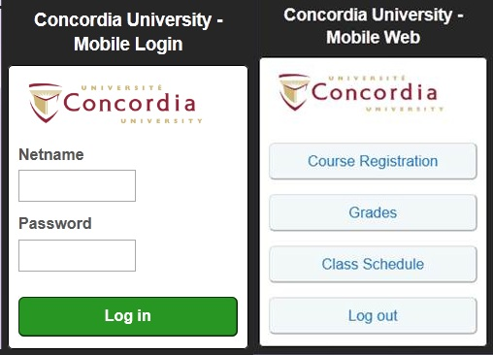

*Only three functionality available: Course Registration, Grades and Class Schedule*

The MyConcordia Application will enable students to have a faster, user friendly, more efficient and more capable on the go experience.

*The Answer of 40 students for the following question: Do you enjoy using the My Concordia Website on your phone?*

*The Answer of 40 students for the following question: Are you willing to pay $2 for the My Concordia Application?*

*The Answer of 40 students for the following question: What would you use in the My Concordia Application on a regular basis?*

The MyConcordia Portal Application will be developed by two teams. Each team will be composed of a Manager, a developer with at least 3 years of expertise in application development and 2 developers with 1-2 years of experience in this domain. Each team will work on a platform. The first team will develop an application for the ApplestoreTM, compatible with the Iphone and the Ipad. The second team will develop an application for Androids and Blackberries. But to be able to have similar application on different platforms, both teams will initially work together with the project supervisor on the different guidelines. This will make the content of the application constant in all platforms and will help the supervisor know what to be expected by each team during development. The most important aspect of the MyConcordia Portal Application is that it requires to have a predefined objective of fast and easy access to the most used functions by students. Our research indicates, thanks to a survey, that the most important functions are:

* Class Schedule (for all the three semesters)
* Student accounts
* Exam Schedule
* Grade
* Moodle
* Registration (for undergraduate and graduate students)
* Concordia Webmail

Some of these functions require more work than the others. A perfect example is the Moodle function. The expectation for this application is for the student to be able to access the Moodle webpage directly from the application and at the same time have a pleasant interface on the smartphone. That represents the biggest challenge for the developers who will need to incorporate this functionality in a user friendly way. At the same time, the registration functionality will be a must have for this application to be successful. But it is considered to be a difficult task depending on the method of implementation. A current problem in the Registration tab in Myconcordia.ca website is that it cannot register more than 600 students at a time. If the Registration functionality in the application is not directly linked to Concordia server, and uses the MyConcordia Portal website than this limitation still remains whereas a direct link to the Concordia servers will mean that registration using the application does not depend on how many students are registering via the website. In other words, depending on the implementation of this functionality, Registration for the students can become smoother (instead of having only 600 students able to register at a given time, it will be possible to have 1200 students registering at the same time) but it also means an increase workload on the developer side. One important functionality is the Concordia Webmail tab. It will be another important part in development as it will need some stylistic changes to accommodate itself to the smartphone and a refresh capability that will inform the student whenever he receives an Email in his Concordia Email. Other functionalities will simply become easier on the eye of the user. A good example is that the class schedule becomes compatible to the Smartphone screen. To be able to guarantee the quality of the application, it is highly encouraged that both team communicate frequently with the maintenance team for the MyConcordia website. Another two functionality that should be added to the application are:

* News
* Annoucement

The first functionality (News) will keep the students inform about current news and event concerning Concordia (as the main page of MyConcordia does). The Second function (Announcement) will be used to indicate to user whenever a maintenance of the application will happen, it will also be used to announce any important changes to the application.

Here is a Small Example of the Application:

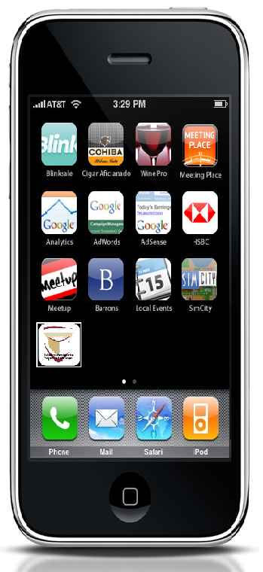

*The highlighted Application is supposedly the MyConcordia application*

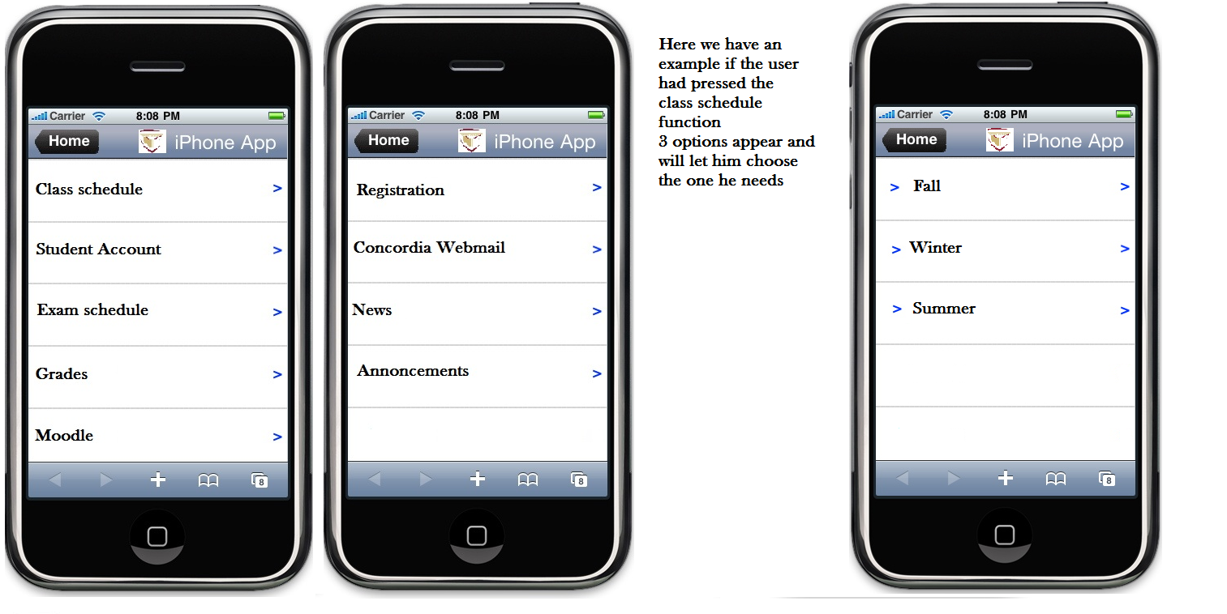

*Here are some snapshot at how the application can be implemented*

It is important to realize that the development of this application can be costly and time-consuming. In the Budget section, we will indicate all the possible costs and profits. In the Schedule of Work section, we will indicate the basic guidelines required to develop the application within a 6 week timeline. The most challenging aspect of this project is that how to implement the program. As it was previously indicated, there is two ways to implement the application:

* Directly linked to the Concordia Server:
  + The Application will be faster because it won’t have to connect to the website initially
  + It will be harder to implement because the platform of the website is unavailable meaning all information must be retrieve from the Concordia Server
  + The Application must also have direct access to the server without interfering with the website
* Linked to the website(not directly linked to the Server):
  + The Application will be slower because it will have to connect to the website initially and then retrieve the information required
  + It will be easier to implement because information will be retrieved directly from the website and then just modified to be visually appealing in the smartphone

We believe that the best way to implement this application would be to link directly the application with the Concordia Server. It will perhaps be harder to implement but it will enable a fast access for students and also enable the developers to use the information retrieved in a more efficient and ultimately more visually appealing interface.

***5.Schedule of Work***

|  |  |
| --- | --- |
| **Week 1** | 1) Determining guidelines for both |
|  | 2) Analyzing Current website, determining possible problems and possible solutions |
|  | 3) Creating a final Blueprint of the program |
|  |  |
| **Week 2** | 4) Starting Development phase for both teams |
|  | 5) Creating a server link between Website and Application |
|  | 6) Implementing a function (grade) to test link |
|  | 7) Creating a pleasant interface (with login credentials) |
| **Week 3** | 8) Creating a smartphone friendly interface for student accounts and class schedule |
|  | 9) Implementing those two function in the Application |
|  | 10) Creating An announcements tab (Will refresh and indicate new announcements) |
|  | 11) Creating a News function giving the newest information about Concordia |
| **Week 4** | 12) Creating an Access to the Concordia webmail (login credentials) |
|  | 13) Creating a Moodle function, that will indicate current classes and enables the |
|  | user to access Moodle to retrieve the available documents and check grades |
|  |  |
| **Week 5** | 14) Creating a Registration Function for undergraduates, graduates |
|  | 15)Creating a function to access registration dates |
|  |  |
|  |  |
| **Week 6** | 16) Testing the application |
|  |  |
|  |  |
|  |  |

*The Schedule of work for the Concordia application*

The Schedule of work is divided in 16 Steps, which are very important to determine progress and also managing the time depending on the on the needs and work for the developers. The 6 weeks of work schedule presented here actually represents 220 hours of work in total (40 hours a week except the last week where only 20 hours are needed). This can greatly vary depending on the developer’s knowledge but also their speed of execution and their experience in such development. This can make the development phase much smoother and faster hence possibly changing the proposed schedule of work. Nevertheless, this schedule would fit most developers and will ensure quality control and at the end less retuning during the testing.

***6. Budget:***

There are multiple expenditures to look out for while developing the application. Here are the possible costs:

|  |  |  |
| --- | --- | --- |
| **Products/Developer** | **Price** | **Hours** |
| iOS developer Enterprise program | $299.00 | N/A |
| Registering in the android market | $25.00 | N/A |
| IPhone /Ipad Developer expert | $32.00 | 220 |
| IPhone /Ipad Developer intermediate | $28.00 | 220 |
| IPhone /Ipad Project Manager | $22.00 | 220 |
| BlackBerry /Android Developer expert | $35.00 | 220 |
| BlackBerry /Android Developer intermediate | $30.00 | 220 |
| BlackBerry /Android Project Manager | $25.00 | 220 |
| **Total** | $50,924.00 | 220 |

*Budget needed to develop the My Concordia Application*

The Product price will be an added $2 in the Technology infrastructure rate for all students. For the 2010-2011 academic year, there were more than 45,000 students enrolled at Concordia. This can mean that there is a possible $90,000 of revenue each semester and 180,000 for each academic year (not including the summer semester). This also means that the university will be able to recoup the cost for this application in only a semester, with even a chance of a $39,000 profit. A part of the profit will be used to keep the development team to do a yearly update to improve to the application and maintaining the standard.

**7. Biographical Background**

This research has been made with the help of Fred M. Movingspear, professor in Concordia University and member of the OIQ (Ordre des Ingenieurs du Quebec) as a senior software engineer. His background includes development of banking application for smartphones, website designing and more importantly 30 years of experience in program development. He also published a few researches including the famous “Programming in the new Millennium”, and the controversial “The disappointments in the hardware industry”. I, Marouen Lamiri, a student in software engineering in Concordia, managed to peak this veterans interest and has been working part-time for 1 year and a half in his research team. During that time, the team of researchers managed to develop a new program for the banking industry and customer service. Being surrounded by this level of experience, I managed to improve drastically while also learning the needs for customer service. That’s why I believe that I’m ready to perform a high scale work that will improve this institution.

**8. Press release:**

The Concordian John H Witley

Public release: 28-Nov-2012

As a student in Concordia University, you must have been wondering when My Concordia portal will be accessible by smartphone and tablets easily and in a user friendly manner. Here is a solution developed by a Concordia student to solve this problem. He proposed to build a My Concordia Portal application for all major smartphone. This app would enable the student to access Registration, class schedule and grades as the previous mobile website could but will also have added functionalities like Moodle and the Concordia webmail to make the application the newest and the most efficient mobile application in Concordia history. What really makes this application a breakthrough is the fact that students will be able to access the portal a quickly, more efficiently and in a user friendly way. You do not need to use the mobile website multiple times to see that it does not give the user a complete package; it simply gives an unsuccessful alternative to students. The application would be complete; the student could do most of his daily and/or monthly work on My Concordia onto their phone. Smartphone have been leading the way in technology and it’s time for Concordia to get follow. The My Concordia application would be huge statement of intent by Concordia to be a University that constantly improves itself. It would be the newest application for my Concordia, the most ambitious and probably the most used one in Concordia history.

Contact information:

[John-H-Witley@Gmail.com](mailto:John-H-Witley@Gmail.com)

514-XXX-XXXX

Journalist, Literature Student (1st year in Masters in English Literature), Concordia 2006-2012

**10. References:**

1. Concordia portal mobile website, Internet: <http://www.m.Myconcordia.ca>, Date: 13/11/2012
2. Concordia portal website, Internet: <http://Myconcordia.ca>, Date: 13/11/2012
3. Oneapp website, Internet: <http://www.oneapp.ca/index-en.html>, Date: 15/11/2012
4. Osx-daily online newspaper website, Internet: <http://osxdaily.com/2010/09/07/iphone-development-costs/>, Date: 16/11/2012
5. Cloud Horizon website, Internet: <http://cloudhorizon.com/montreal-iphone-application-development-and-design/>, Date: 16/11/2012
6. Read-Write Forum website, Internet: <http://readwrite.com/2009/11/02/13_tools_for_building_your_own_iphone_app>, Date:16/11/2012
7. App-Development Company website, Internet: <http://appdevelopermontreal.com>, Date: 16/11/2012
8. Survey, 40 Students in Concordia, MyConcordia Satisfaction survey, Date:11/11/2012-20/11/2012